MARS
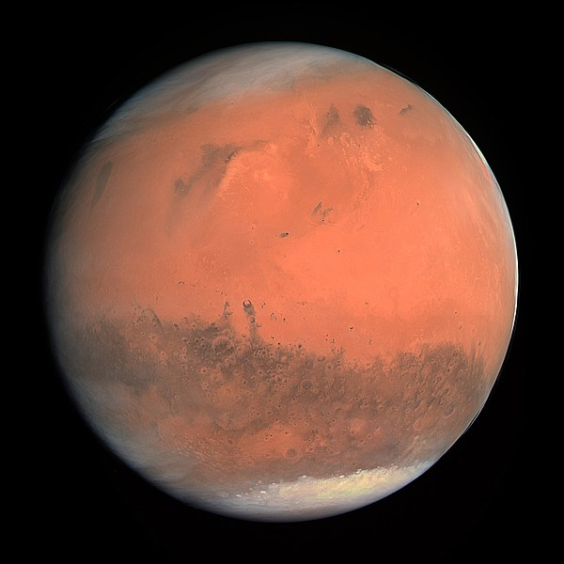

How did Mars get its name:
Mars is the fourth planet from the Sun and is one of the terrestrial planets. It has a distinctive red color and was therefore associated with battles and war and named after the Roman god of war.
The surface of Mars is a reddish-brown color due to the rusting process of the surface minerals. Another name for Mars is “The Red Planet.
Other civilizations throughout history have also named the planet due to its color. The Ancient Egyptians called Mars “the red one.”
Today we often call Mars the “Red Planet” due to the iron minerals on the surface.

Formation:
Around 4.5 billion years ago our solar system settled into the configuration that we see today.
Mars was formed when the swirling gas and dust WITH THE HELP OF gravitational pull and created the fourth plant from the sun.

Mars is a terrestrial planet with a central core, rocky mantle, and a solid crust.

Structure and Surface:
The core at Mars’ center is very dense and is between 1,500 to 2,100 km in radius.
The core is made up of iron, nickel and sulfur. Surrounding the core is the planet’s rocky mantle which is between 1,240-1,880 km thick.
Above the rocky mantle is the crust made up of iron, magnesium, aluminum, calcium, and potassium. The crust is between 6-30 mi/10-50 km deep.
One of the most distinctive features on Mars is its “channels.” These channels look like they could have been made by running water.
Mars actually has many more colors than just the “red” that most people use to describe it. At the surface we see colors such as gold, tan, and brown.
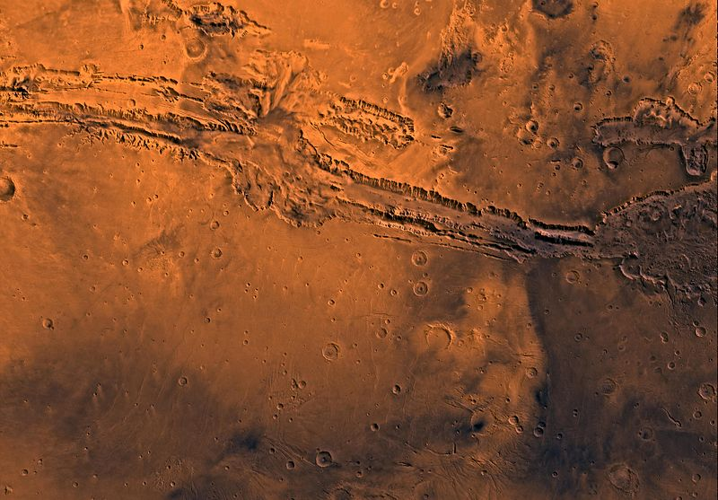
Mars is only half of Earth’s diameter and its surface has many appearances as the dry land on Earth.
Mars has volcanoes, crust movement, impact craters, and atmospheric conditions such as dust storms that, over the years, has changed the landscape.
Valles Marineris is a large canyon system on Mars whose length is long enough to stretch from New York to California on Earth; with a distance of over 3,000 mi/4,800 km.
At its widest point, the canyon is 200 mi/320 km and 4.3 mi/7 km at its deepest. To compare this to Earth, it is nearing ten times the size of the Grand Canyon.
Mars also has the solar system’s largest volcano, Olympus Mons. The volcano is three times taller than Mt. Everest on Earth and has a base that is the size of the state of New Mexico.
Thanks to the incredible Mars rovers, we believe that Mars had water on its surface in the past.
There is evidence of ancient river valley networks, lakebeds, and deltas as well as minerals and rocks on the surface that are only formed when there is liquid water.
Some of the features on the surface of Mars suggest that around 3.5 billion years ago, the planet experienced huge floods.
Today, any water that is found on Mars is in the form of water-ice just below the surface in the polar regions, as well as salty or briny water which flows down some of the crater walls and hillsides at various times of the year.

The atmosphere on Mars is too thin for liquid water to remain on the surface.

Atmosphere

The atmosphere of Mars is made up of 95% carbon dioxide

The temperature on Mars never goes any higher than 20 degrees C and and as low as /-153 degrees C.
The Mars winds can create incredibly strong dust storms that cover a lot of the planet.
Mars doesn’t have a magnetic field.
Mars does have two small moons: Phobos and Deimos. It’s believed that these may have actually been asteroids that were captured.

Could Life Exist on Mars?
Scientists don’t think that they will ever find living things on Mars as the conditions aren’t good enough for life to thrive. However, they are seeking signs that life might have existed on the planet a long time ago when Mars was warmer and had liquid water covering its surface.

FUNNY Facts about Mars :
- There have been 40 missions to Mars, but only 18 of the missions were successful.
- The dust storms on Mars are so large that they are considered to be the biggest in the solar system.
- Meteorites that have been ejected from Mars have been found all over the Earth.
- Of all of the planets in the solar system, only Earth has confirmed life and Mars is believed to possibly be hospital for life.
- Earth and Mars are the only to planets in the solar system with polar ice caps.
- Mars does have seasons but they are twice as long as the seasons on Earth due to Mars’ axis tilt.
- If you were standing on Mars and looked at the sun it would appear half the size as compared to looking at the sun from Earth.

THE EARTH
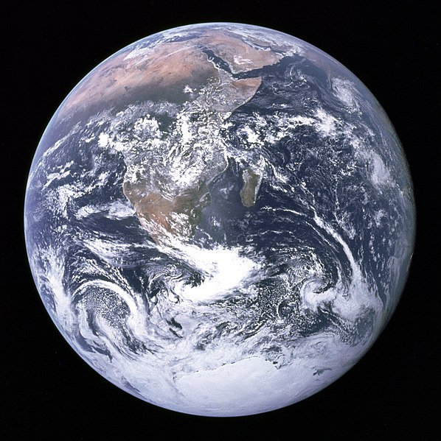

How did Earth get its name:

It’s believed that the name “Earth” is around 1,000 years old. If you notice, except for Earth, all of the planets in our solar system are named after Roman and Greek gods and goddesses. One idea of the source of the name is that the word “Earth” is an old Germanic word that really just means “the ground.”:

Another thought is that the name “Earth” is derived from the Old English word “ertha” as well as the Anglo-Saxon word “erda”, which means soil or ground.

About 4.5 billion years ago, our solar system settled into the layout that we see today. It’s believed that Earth formed when gravity began pulling dust and swirling gas together, and the Earth became the third planet from the sun. Earth is one of the terrestrial planets, which means it has a central core, rocky mantle, and a crust that is solid.
Our Earth orbits the sun every 23.9 hours and it takes 365.23 days to complete an entire trip around the sun. The axis of rotation of the Earth is tilted 23.4 degrees and it’s this tilt that gives us our seasonal cycles every year.

Structure and Surface:
The Earth is made up of four main layers, beginning with the planet’s inner core which is enveloped by the outer core, then the mantle, and finally the crust. The inner core is around /1,221 km in radius and is a solid sphere of nickel and iron metals.
The temperature of the inner core is as high as 5,400 degrees C. Surrounding the inner core is the outer core. The outer core is made up of iron and nickel fluids.
Between the outer core and the crust is the mantle which is the thickest of all of the layers. This is a hot, thick mixture of molten rock that has the consistency of caramel and is around 2,900 km thick.
It is divided into huge plates called “tectonic plates” that are constantly in motion. This movement causes the plates to collide to create mountains, split or separate, or rub against each other and create earthquakes.
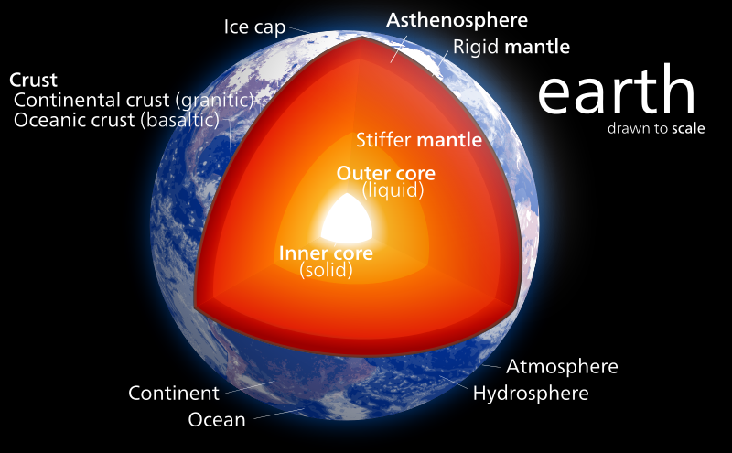
The Earth has an ocean that covers almost 70% of the surface of the planet. The average depth of the ocean is around 2.5 mi/4 km and contains 97% of the water on the Earth.
Almost every one of the volcanoes on Earth is hidden under these oceans. The Mauna Kea volcano in Hawaii is taller from the base to the top than Mount Everest, but a majority of the volcano is underwater.
The longest mountain range on Earth is also underwater, at the bottom of the Atlantic and Arctic oceans. This mountain range is four times longer than the Rockies, Andes, and Himalayas all combined.
The land masses that make up 30% of the Earth’s surface are incredibly varied. Land has continents, islands, and other land masses as well as sources of fresh water.
Many scientists believe that water was delivered to the Earth by comets and asteroids as it was forming and that much of the water was inside the planet and then brought up to the surface during volcanic activity.

Atmosphere
Earth’s atmosphere consists of 78% nitrogen, 21% oxygen and trace amounts of other gases including carbon dioxide, argon, and neon. We give credit to the plant life on Earth for generating the large amount of oxygen.
The magnetic field of Earth is incredibly powerful and also plays a big part in protecting our planet from the effects of solar wind. It’s though that the Earth’s magnetic field is due to the planet’s core, which is made up of nickel-iron, combined with the fast rotation of the Earth.

Could Life Exist?
If you look around our Earth you can see that we have an incredible amount of life that exists on both the land and within the waterways and seas. Scientists have always based our definition of “life” as the carbon-based type that we have around us, including ourselves.
They established three rules that are required for life: liquid water, some source of energy such as our sun, and a source of food.
Earth isn’t too hot and isn’t too cold, and this is often called the “Goldilocks distance.” Our moon has created the tides on Earth, which in turn has helped life to develop.

Facts about Earth for Kids:
- The shape of the Earth is actually closer to a squashed sphere. It’s fatter in the middle near the equator where gravity pushes to create a bulge.
- Even though you might think you are standing still, the Earth is turning. The speed at the equator is around 1,000 mph.
- The Earth is also moving through the solar system at around 67,000 mph/107,826 kph.
- Earth is constantly recycling its material through tectonic movement which drags surface rocks back down below the surface to become magma and then is spewed back out from volcanoes.
- Earthquakes are the result of tectonic plate movement on the planet. The largest earthquake recorded in the U.S. was in 2016 in Alaska, registered at 9.2 on the Richter Scale; with the largest global earthquake recorded in 1960 in Chile, registering 9.5 on the Richter Scale.
- The hottest recorded temperature location on the Earth is in El Azizia, Libya with temperatures hitting 136 degrees F/57.8 degrees C in 1922.
- The coldest temperature location is in Antarctica with temperatures reaching -100 degrees F/-73 degrees

