Before the presentation
- Is Venus the only name for the planet? What other connotations of Venus do you know? The pictures below might help you.
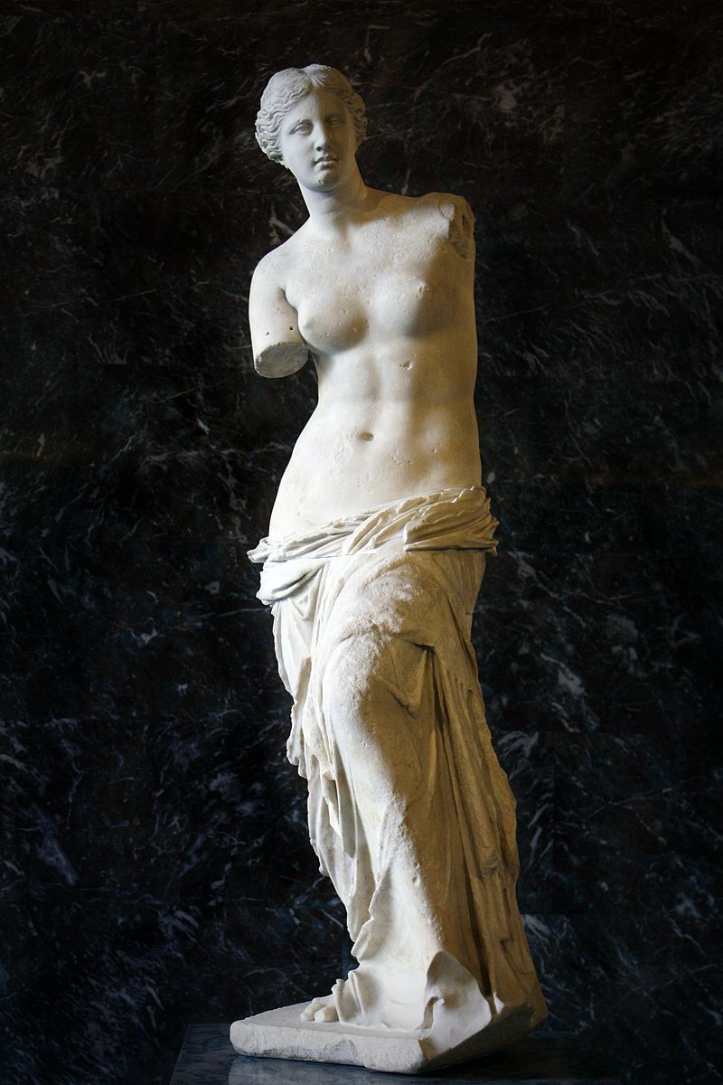
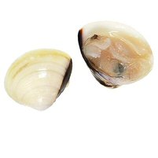
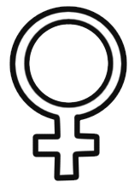
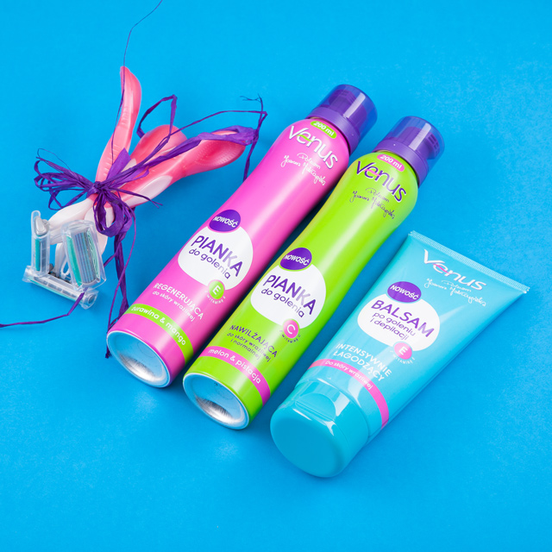
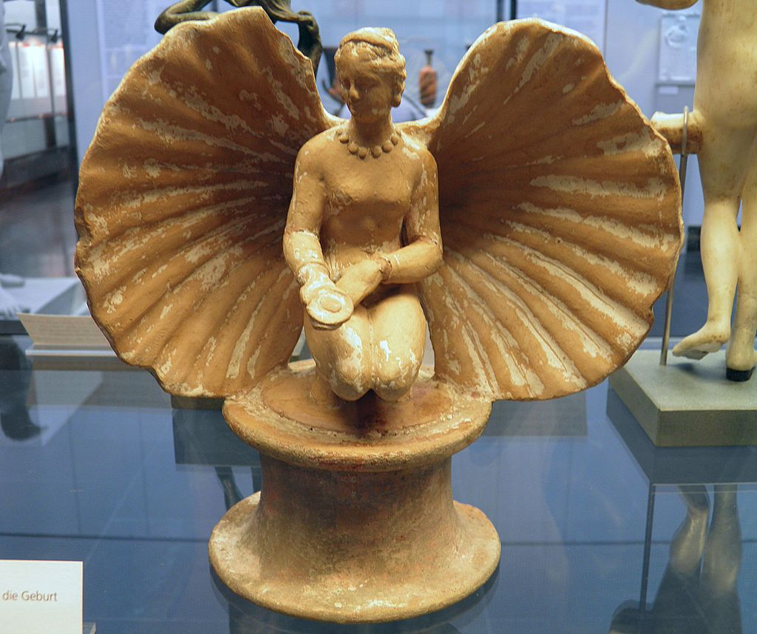
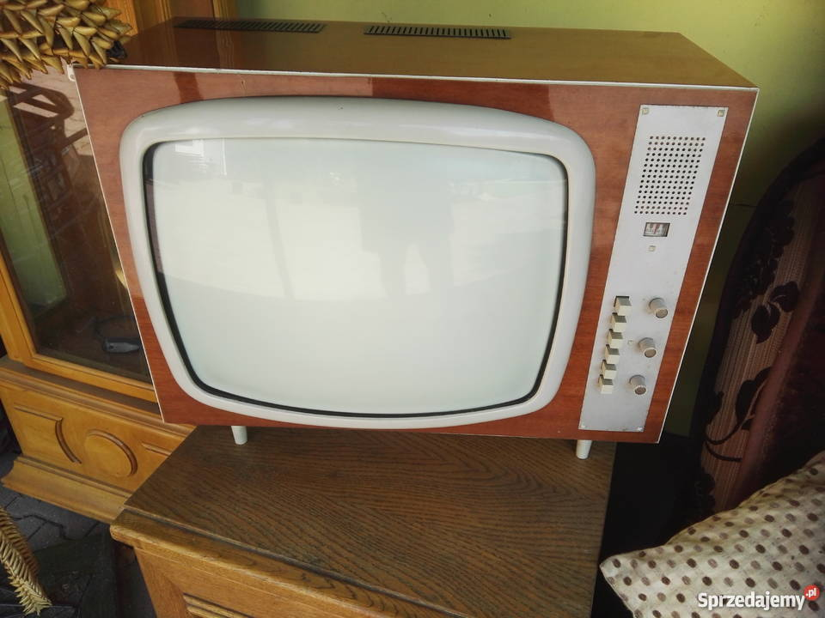

- Can you say the dates?
22000 B.C 476 A.D 20s 16th century 1492 21st century
While - watching the presentation
- Try to put the periods in a chronological order (1 – 12).
BAROQUE THE TWENTIES CLASSICISM MIDDLE AGES NOWADAYS ANCIENT ROME
THE SIXTIES PREHISTORY ANCIENT EGIPT ROCOCO THE NINETIES ANCIENT GREECE
After the presentation
- Do you agree with the last sentence of the presentation? Why/ Why not?

- Jon Gray, a Texan man, without psychological education wrote a book in 1992 „Men are from Mars, women are from Venus”. What makes a man and a woman different?

You can use ideas such as: intelligence, social skills, aggression, domination, showing emotions, appearance, fertility, behaviour, interests …

WOMEN
MEN

- Imagine an ideal woman of the 21st century. Draw a group picture. Think of the character features, too. Present your ideas in front of the class. Have fun!

You can use the ideas such as:
general appearance | age | hair | height | build | face | personality
pretty, attractive, ugly, beautiful, pierced, tattooed … | young, elderly, middle-aged, teenager,  old … | short, dark, fair, medium-lenght, ponytail, ginger, long, wavy, curly, straight … | short, tall,  of medium height … | slim, fit, well-built, plump, fat, skinny,  overweight,  thin … | oval, square, round, triangle, freckles,  wrinkles … | honest,  ambitious, generous, mean, messy, self-confident, easy-going, crazy, brave, serious, helpful, rude, quiet, tidy, shy, cross …

THANK YOU! HAVE A NICE DAY IN BULGARIA!

